Vision Statement of the Department.
To be a preferred hub for nurturing computer engineering aspirants through innovative, ethical, value-based technical education, impactful research, and industry collaboration, to become successful professionals contributing for the betterment of society.
Mission Statement of the Department.
To nurture computer engineering professionals by offering Dynamic learning environment that encourages problem-solving using emerging technology, National Education Policy aligned evidence-based technical education, fostering ,innovation, research, and industry–institute collaboration & Holistic, ethical and sustainable development for lifelong success.

Session 2026-2027
Vision:Dream of where you want. | Mission: Means to achieve Vision
Program Educational Objectives of the program (PEO): (broad statements that describe the professional and career accomplishments)
PEO1 | Preparation | P: Preparation | Pep-CL abbreviation pronounce as Pep-si-lL easy to recall
PEO2 | Core Competence | E: Environment  (Learning Environment) | Pep-CL abbreviation pronounce as Pep-si-lL easy to recall
PEO3 | Breadth | P: Professionalism | Pep-CL abbreviation pronounce as Pep-si-lL easy to recall
PEO4 | Professionalism | C: Core Competence | Pep-CL abbreviation pronounce as Pep-si-lL easy to recall
PEO5 | Learning  Environment | L: Breadth (Learning in diverse areas) | Pep-CL abbreviation pronounce as Pep-si-lL easy to recall
Program Outcomes (PO): (statements that describe what a student should be able to do and know by the end of a program)
Keywords of POs:
Engineering knowledge,Problem analysis, Design/development of solutions,Conduct Investigations of Complex Problems, Engineering Tool Usage, The Engineer and The World,Ethics, Individual and Collaborative Team work,Communication, Project Management and Finance, Life-Long Learning
PSO Keywords: Cutting edge technologies, Research
“I am an engineer, and I know how to apply engineering knowledge to investigate, analyse and design solutions to complex problems using tools for entire world following all ethics in a collaborative way with proper management skills throughout my life.” to contribute to the development of cutting-edge technologies and Research.
Integrity: I will adhere to the Laboratory Code of Conduct and ethics in its entirety.

Name and Signature of Student and Date
(Signature and Date in Handwritten)
Vision Statement of the Department.
To be a preferred hub for nurturing computer engineering aspirants through innovative, ethical, value-based technical education, impactful research, and industry collaboration, to become successful professionals contributing for the betterment of society.
Mission Statement of the Department.
To nurture computer engineering professionals by offering Dynamic learning environment that encourages problem-solving using emerging technology, National Education Policy aligned evidence-based technical education, fostering ,innovation, research, and industry–institute collaboration & Holistic, ethical and sustainable development for lifelong success.
Session | 2024-25 (ODD) |  | Course Name | Web Technology Lab
Semester | 3 |  | Course Code | 23CT1301
Roll No |  |  | Name of Student
Practical Number |  | 3
Course Outcome |  | - Understand various internet technologies.  - Design the web pages using HTML and CSS.  - Implement the XML technology to store the data.  - Develop the interactive web pages using JavaScript.
Aim |  | Develop and demonstrate the usage of inline, internal and external style sheet using CSS.
Problem Definition |  | To develop and demonstrate a web page using CSS and understand the usage of inline, internal, and external style sheets. A class timetable is designed as the web page, where CSS is used to apply different background colors, formatting, alignment, and styling to various elements of the timetable
Theory  (100 words) |  | CSS (Cascading Style Sheets) is used to control the appearance and layout of HTML elements. CSS can be applied to an HTML document in three ways: inline, internal, and external. Inline CSS is written directly inside an HTML element using the style attribute and is useful for applying styles to a specific element. Internal CSS is written inside the <style> tag within the <head> section and applies styles to a particular web page. External CSS is written in a separate .css file and connected to HTML using the <link> tag. External CSS is useful for maintaining consistent styling across multiple web pages.
Procedure and Execution  (100 Words) |  | Step for Implementation: 1. Open a text editor such as VS Code or Notepad.  2. Create a new HTML file and save it as index.html.  3. Create a separate CSS file and save it as style.css.  4. Create the basic HTML structure using <html>, <head>, and <body> tags.  5. Design a class timetable using HTML table elements such as <table>, <tr>, <th>, and <td>.  6. Link the external CSS file with the HTML document using the <link> tag.  7. Define different CSS classes in the external stylesheet to apply colors and formatting to the timetable.  8. Use inline CSS where required to demonstrate styling directly within HTML elements.  9. Use internal CSS inside the <style> tag to demonstrate internal styling.  Save both files and open the HTML file in a web browser to observe the styled timetable.
Code: HTML:
<!DOCTYPE html>
<html lang="en">
<head>
<meta charset="UTF-8">
<meta name="viewport" content="width=device-width, initial-scale=1.0">
<link rel="stylesheet" href="t.css">
<title>Document</title>
</head>
<body>
<h1><center>TIMETABLE <br>COMPUTER TECHNOLOGY <br>SECTION:A </center></h1>
<table border="1" cellpadding="10" cellspacing="0", allign="center">

<tr class="time">

<th>DAY</th>
<th>10 am - 11 am</th>
<th>11 am - 12 pm</th>
<th>12 pm - 01 pm</th>
<th>02 pm - 03 pm</th>
<th>03 pm - 04 pm</th>
<th>04 pm - 05 pm</th>

</tr>

<tr>
<td allign="center" class="d">MONDAY</td>
<td allign="center" class="ds">DATA STRUCTURE</td>
<td allign="center" class="co">COMPUTER ARCHITECTURE AND ORGANIZATION</td>
<td allign="center" class="r">LUNCH BREAK</td>
<td allign="center" class="dm">DISCRETE MATHEMATICS AND PROBABILTY THEORY</td>
<td colspan="2" allign="center" class="lab">LAB :DATA STRUCTURE <br> LAB:WEB TECHNOLOGY </td>
</tr>

<tr>
<TD allign="center" class="d">TUESDAY</TD>
<TD allign="center" class="dm">DISCRETE MATHEMATICS AND PROBABILTY THEORY</TD>
<TD allign="center" class="fo">FUNDAMENTALS OF ECONOMICS AND MANAGEMENT</TD>
<TD allign="center" class="r">LUNCH BREAK</TD>
<TD allign="center" class="cl">CYBER LAWS</TD>
<TD allign="center"colspan="2" class="lab">LAB :DATA STRUCTURE <br> LAB:WEB TECHNOLOGY</TD>
</tr>
<tr>
<td allign="center" class="d">WEDNESDAY</td>
<td allign="center" class="blank"></td>

<td allign="center" class="cl">CYBER LAWS</td>
<td allign="center" class="co">COMPUTER ARCHITECTURE AND ORGANIZATION</td>
<td allign="center" class="r">LUNCH BREAK</td>
<td allign="center" class="fo">FUNDAMENTALS OF ECONOMICS AND MANAGEMENT</td>
<td allign="center" class="ds">DATA STRUCTURE</td>
</tr>

<tr>
<td allign="center" class="d">THURSDAY</td>
<td allign="center" class="fo">FUNDAMENTALS OF ECONOMICS
AND MANAGEMENT
</td>

<td allign="center" class="ds">DATA STRCUTURE</td>
<td allign="center" class="cl">CYBER LAWS</td>
<td allign="center" class="r">LUNCH BREAK</td>
<td allign="center" class="dm">DISCRETE MATHEMATICS AND PROBABILTY THEORY</td>
<td allign="center" class="sp">SPORTS</td>
</tr>

<tr>
<td allign="center" class="d">FRIDAY</td>
<td allign="center" class="ds">DATA STRUCTURE</td>
<td allign="center" class="co">COMPUTER ARCHITECTURE AND ORGANIZATION</td>

<td allign="center" class="r">LUNCH BREAK</td>
<td allign="center" class="fo">FUNDAMENTALS OF ECONOMICS AND MANAGEMENT</td>
<td allign="center" class="sp">Help desk</td>
<td allign="center" class="sp">Help desk</td>
</tr>
<TR>
<TD allign="center" class="d">SATURDAY</TD>
<td colspan="6" allign="center" class="iv"><Center>Holiday</Center></td>
</TR>

</table>
CSS:
body{
background-color: #e5dbd1;
}
.time{
background-color: rgb(0, 255, 157);
}
.r{
background-color: rgb(132, 0, 255);
}
.d{
background-color: rgb(255, 80, 194);
}
.iv{
background-color: rgb(255, 0, 0);
}
.ds{
background-color: #06f47d;
}
.co{
background-color: rgb(241, 118, 192);
}
.dm{
background-color: rgb(220, 255, 227);
}
.fo{
background-color: rgb(139, 58, 0);
}
.cl{
background-color: rgb(177, 123, 234);
}
.lab{
background-color: rgb(6, 250, 63);
}
.sp{
background-color: rgb(224, 128, 10);
}
.blank{
background-color: rgb(212, 255, 196);
}

Vision Statement of the Department.
To be a preferred hub for nurturing computer engineering aspirants through innovative, ethical, value-based technical education, impactful research, and industry collaboration, to become successful professionals contributing for the betterment of society.
Mission Statement of the Department.
To nurture computer engineering professionals by offering Dynamic learning environment that encourages problem-solving using emerging technology, National Education Policy aligned evidence-based technical education, fostering ,innovation, research, and industry–institute collaboration & Holistic, ethical and sustainable development for lifelong success.
 | Output: 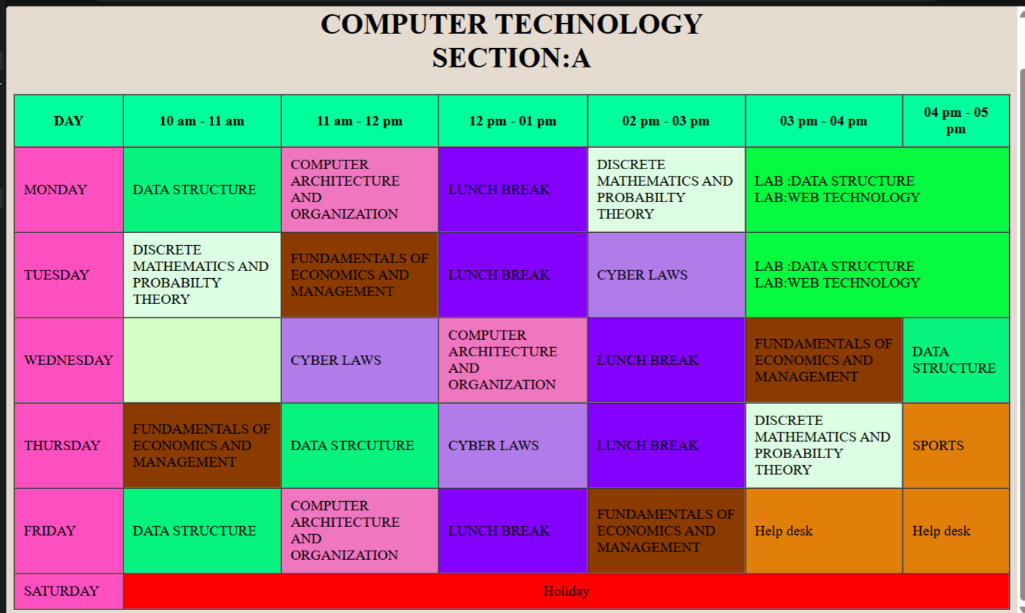
Output Analysis | The class timetable was successfully created and displayed in the web browser. Different background colors and formatting were applied to the timetable using CSS. The external stylesheet was successfully linked with the HTML file, demonstrating the use of external CSS. Inline and internal CSS can also be used to apply styles directly to specific elements or within the HTML document. The output clearly shows the effect of CSS on different table cells and elements.
Link of student Github profile where lab assignment has been uploaded | https://github.com/shakulvilasrathod-art/Web-technology
Conclusion | The practical successfully demonstrated the use of inline, internal, and external style sheets in CSS. A class timetable was created using HTML table elements and styled using different CSS properties. The experiment helped in understanding how CSS improves the appearance, readability, and presentation of HTML web pages.
Plag Report (Similarity index < 12%)
Date | 16-08-2026

